Mule OAuth 2.0 Provider

Mule OAuth 2.0 Provider is an OAuth 2.0 provider alternative developed by MuleSoft that can be used in any organization.

In addition to Mule OAuth 2.0 Provider, Mulesoft offers out-of-the-box integration with PingFederate, OpenAM and Open ID Connect OAuth 2.0 Providers.

Mule OAuth 2.0 Provider Configuration

To run the Mule OAuth Provider in conjunction with the OAuth 2.0 Access Token Enforcement Using External Provider policy, you have to deploy the OAuth provider to a runtime with API Gateway capabilities (either Mule runtime engine v3.8.0 or later, or API Gateway v2.x.x) with the corresponding organization credentials correctly specified.

Getting the OAuth Provider

You can download the OAuth Provider from Exchange.
See the External OAuth 2.0 server for Anypoint Platform asset in Exchange to download it.

If you want to use this provider in Mule 4, see OAuth2 Provider Module Reference.

Configuring Endpoint Paths

The Provider has three main endpoint paths that should be defined.

Default paths:

Path | Description
/validate | Verifies the validity of the token.
  You may define more than one validation endpoint, each of them enforcing different scopes. See Configuring Scopes for more information about this.
/authorize | Provides a one-time-use code to be exchanged by an actual token when calling /access_token.
/access_token | Returns an OAuth 2.0 token.

Configuring Scopes
OAuth 2.0 scopes are a way to further limit access to a resource protected by OAuth. You may define words like READ, WRITE, or some other words that make sense in the context of your organization (eg. CONTRACTOR, PUBLIC, EMPLOYEES_ONLY, etc).

You can define scopes in three different places.
- You can configure your scopes in the universal set, defaultScopes, where you define all possible scopes.
- You can also configure the validation endpoint, /validate, to enforce a particular subset of the previously defined scopes.
- Or you can enforce scopes by specifying a space-separated list in the policy itself.
For example:
<oauth2-provider:config
scopes="CONTRACTOR, PUBLIC_READ, EMPLOYEES_ONLY, WRITE">
...
</oauth2-provider:config>

OAuth 2.0 Policy Prerequisites

Prerequisites for using an OAuth 2.0 policy are:
- Having the necessary permissions for creating or managing APIs.
- Applying the policy to the API instance so the associated resource is protected.
- Having a client application created in API Platform and registered to the API instance.
- Having an OAuth 2.0 Provider to issue a token based on the client application credentials and capable of validating it.
If you are using a Mule OAuth 2.0 Provider, your runtime must also be correctly configured with the organization credentials.
- [API instance RAML-based] A Security Scheme should be specified in the RAML if you would like to use API Console with OAuth dance capabilities.

If a resource is protected by an OAuth token enforcement policy, an OAuth token will be required to be specified in all requests sent to the protected resource either as a query parameter or an authorization header. The following table summarizes this usage:

Places to include Token | Example | Notes
Query parameter | ?access_token=123 | Included as part of the URI
Authorization header | Authorization:Bearer 123 | The header consists of a key:value pair, where Authorization is the key and the value is composed as follows: "Bearer" + <space> + <token, for example, 123>

If the API instance is RAML-based, declare the protected resources as protected by OAuth in order for the API Console to be aware of the policy being applied.

Mule OAuth 2.0 Access Token enforcement

To secure an API in Anypoint Platform using OAuth, we recommend using one of the following policies:
- OpenAM OAuth Token Enforcement policy
- PingFederate OAuth Token Enforcement policy
- OpenID Connect Access Token Enforcement Policy
An authorization enforcement policy, which you apply to an API in Anypoint Platform, connects to an OpenAM authorization server, PingFederate authorization server, or OpenID Connect Token Introspection endpoint.

To use one of these policies, set up client management for the corresponding OpenAM, PingFederate, or Dynamic Client Registration-compliant identity provider. If you can’t set up one of these identity providers, and therefore can’t use one of the recommended policies, use the OAuth 2.0 Access Token Enforcement Using External Provider policy, which uses Mule as the identity provider.

Note the following requirements and restrictions:

- To use the OAuth 2.0 Access Token Enforcement Using External Provider policy, you need a Mule OAuth 2.0 provider to provide an access token. You can’t use any other OAuth 2.0 provider, such as Facebook, Google, or Azure.
- Like other API Manager-enforced policies, the API needs to be registered in API Manager to apply and use any OAuth 2.0 access token policy.
- None of the token enforcement policies work with a Mule client app to access OAuth 2.0-protected resources outside Anypoint Platform. Configure the HTTP Requester connector for this purpose.

OAuth 2.0 Dance and OAuth 2.0 Access Token Enforcement

The authentication process performed by the Mule OAuth 2.0 provider, API, and client application conforms to RFC 6749. This process is called the OAuth Dance.

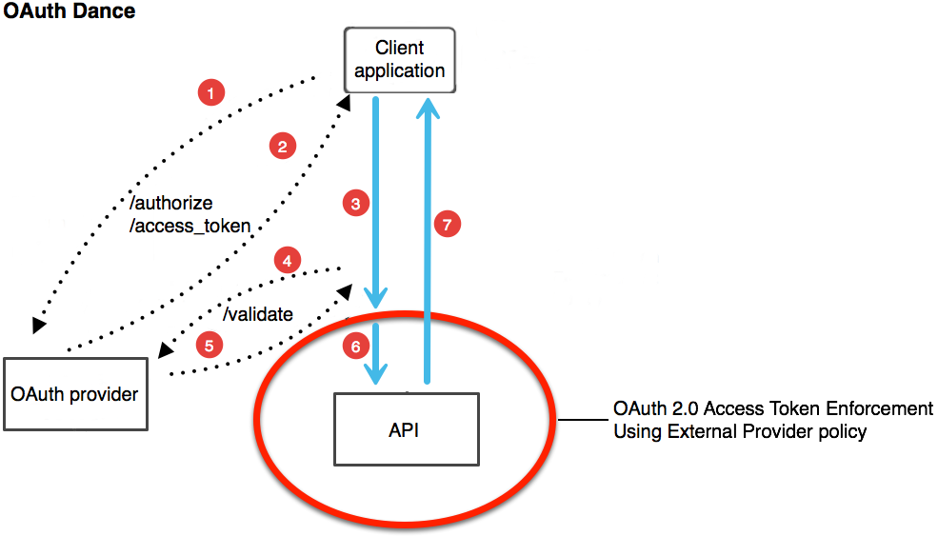
1. A token is requested to the provider, specifying client application credentials as needed (the credentials correspond to a Client ID and secret generated by API Platform).

2. Mule OAuth 2.0 provider returns a token.

3. An HTTP request is performed against the protected resource (ie resource where the OAuth 2.0 Access Token Enforcement policy is applied), including the token either as an authentication header or a query parameter.
- The protected resource is linked with the API definition through Autodiscovery.

4. The OAuth 2.0 Access Token Enforcement policy intercepts this request and communicates with the Provider to validate the token.

5. If the token is correctly validated:
- The token is whitelisted and kept on record until expiration. Any further requests that contain this token are not validated against the OAuth provider.
- The associated client ID of the client application credentials is checked to make sure that the application has an active contract with the API. (Not Applicable to OpenAM)

6. The request is forwarded to the resource.

7. An HTTP response is generated.

The requester gets authorization from an OAuth provider instead of directly gaining access to the credentials of the client application. The client application owner, owns the credentials and authorizes the provider to interact with the API. The protected resource knows the user is authorized because it has a valid access token.

OAuth 2.0 Grant Types

OAuth 2.0 specify the following methods (ie Grant Types) for requesting for a token.

- AUTHORIZATION_CODE
- IMPLICIT
- RESOURCE_OWNER_PASSWORD_CREDENTIALS
- CLIENT_CREDENTIALS

For those RAML-based APIs in which the RAML should be updated with the OAuth 2.0 security schema, the following table maps the RAML grant types to the grant type names in the OAuth 2.0 policy configuration.

Authorization Grant Types Defined in RAML Definition | Equivalent Authorization Grant Type to Enable in the OAuth Provider Policy | Supported in embedded APIkit Console?
[implicit] | Implicit | Yes
[client_credentials] | Client Credentials | No
[password] | Resource Owner Password Credentials | No
[authorization_code] | Authorization Code | Yes

Authorization Code grant type

The Authorization Code grant type is the most frequently used grant type and the most secure.

To get a token using this grant type, the following information needs to be specified in the HTTP request to the Provider:

- Client ID of the client application
- Client Secret of the client application
- Redirect URL as specified on the client application definition

Assuming that the provider is accessible on http://localhost:8081 and the redirect URL of your client application is "http://localhost:1234":
Request authorization:
curl “http://localhost:8081/authorize” -d “response_type=code&client_id=<application Client ID>&scope=&redirect_uri=http://localhost:1234” -X POST

The login page appears in the browser. After the user logs in, the provider sends a redirect to the redirect_uri. This redirect includes additional properties, including an access code.
Response:
http://localhost:1234/?code=<authorization code>#/login

Send the access code to the token endpoint in a request that also includes the client ID, the client secret and some of the information in the previous call:
Request token:
curl “http://localhost:8081/access-token” -d “grant_type=authorization_code&client_id=<application Client ID>&client_secret=<application Client Secret>&code=<authorization code>&redirect_uri=<http://localhost:1234 as in the previous request>” -X POST

JSon Response:
{
"expires_in":86400,
"token_type":"bearer",
"refresh_token":"<oauth refresh token>",
"access_token":"<oauth token>"
}

Implicit

The implicit grant type is not as secure as, but easier to use than the authorization code grant type. Javascript clients and mobile applications often use this grant type. The authorization server issues an access token directly and skips the step of issuing an intermediate access code.

Assuming that the provider is accessible on http://localhost:8081 and the redirect URL of your client application is "http://localhost:1234":

Invoke the authorization endpoint with a request that includes the client ID, the type of authorization you want to perform, the redirect URL, and the scopes you want to authorize. The structure of the request should look like the URI below:

Request token:

curl “http://localhost:8081/authorize” -d “grant_type=implicit&client_id=<application Client ID>&redirect_uri=http://localhost:1234&response_type=token” -X POST

This displays the login page in the browser. After the user logs in, the provider sends a redirect to the redirect_uri. This redirect already includes the token, not just an access code:
Response:
http://localhost:1234/#access_token=<oauth token>&token_type=bearer&expires_in=86400

Resource Owner Password Credentials

The resource owner password credentials grant type is less secure than both the implicit and the authorization code grant types. The client needs to handle the user’s credentials. This requires that users have a high degree of trust in the client. This grant type is often used when the consumer of the protected resource is a widget of the same service.

Assuming that the provider is accessible on http://localhost:8081 :
Send a POST request to the token endpoint that includes the user name and password:
Request token:
curl "http://localhost:8081/access-token” -d “grant_type=password&response_type=token&username=<username>&password=<password>&client_id=<application client ID>&client_secret=<application client secret>" -X POST

JSon Response Example:
{
"expires_in":86400,
"token_type":"bearer",
"refresh_token":"<refresh oauth token>",
"access_token":"<oauth token>"
}

Client Credentials

The client credentials grant type is the least secure grant type. Use this grant type when the client is the resource owner or an authorization has previously been arranged with the authorization server. In this grant type, an access token is obtained if the client identifier and the client secret are valid.

Assuming that the provider is accessible on http://localhost:8081 and the redirect URL of your client application is "http://localhost:1234":
Send a POST request to the token endpoint that includes the user name and password:
Request token:
curl “http://localhost:8081/access-token” -d “grant_type=client_credentials&client_id=<application client ID>&client_secret=<application Client Secret>&response_type=token” -X POST

JSon Response:

http://localhost:1234/#access_token=<oauth token>&token_type=bearer&expires_in=86400

Mule OAuth 2.0 Client Store Configuration

Mule OAuth 2.0 Client Store allows the Mule OAuth 2.0 Provider to use Anypoint Client Applications for token generation.

This feature is available for Mule 4.2.0 and later.

OAuth 2.0 Client Store Properties

The Object Store has two configurable properties:

anypoint.oauth_provider.cache_persistence_enabled | Defines whether the caching mechanism should persist locally. The default value is true if the property is not set or cannot be parsed. Cache persistence allows client authorization without connection to Anypoint Platform.
anypoint.oauth_provider.cache_ttl_days | Represents how many days each Client Application should be cached by the OAuth Server. This value can be any positive floating point number. The default value is 30, representing 30 days.

Token Cache

To prevent downtime of the Mule OAuth 2.0 provider due to errors when connecting to the platform, the Mule OAuth Client Store caches each valid Client Application for which a token is requested. If the Mule OAuth 2.0 provider requests a new token while there is no connection, the OAuth 2.0 Client Store fallbacks to the cache. The expiration of its entries has a default of 30 days. Additionally, you can configure this range, and even set it to persist the cache locally to ensure service availability in case of a restart or lack of connection to the platform. In case a Client Application for which a token already exists in the Client Store is removed from Anypoint Platform, on the next token request, the Client Store will remove the Client from the cache, mirroring the platform status.

Configuring Oauth 2.0 provider for an API

1. Register a new oauth application in github as following
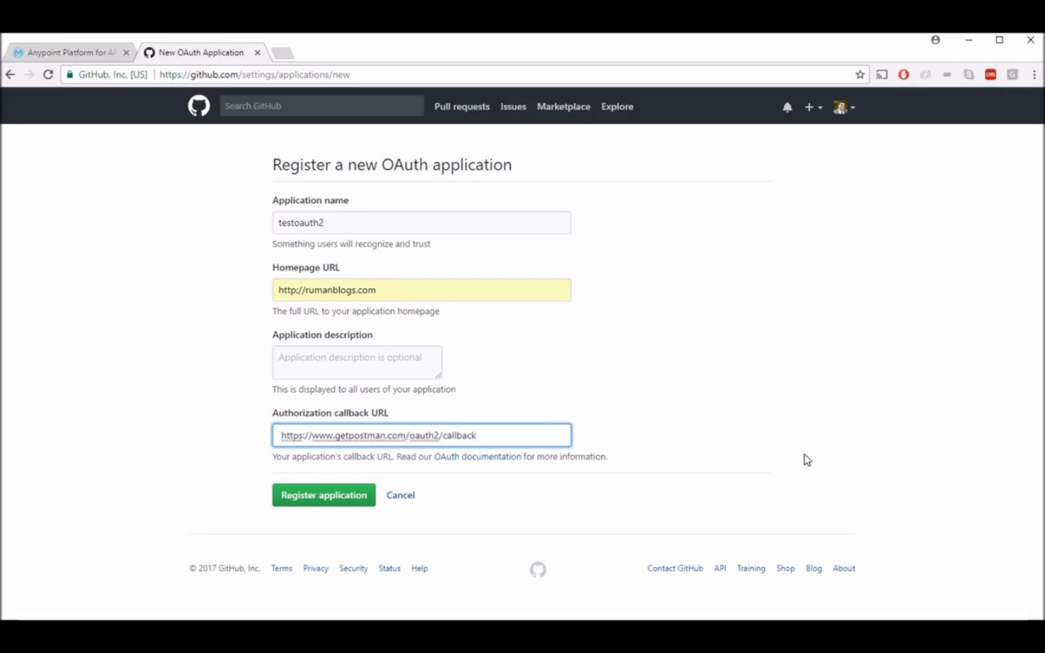

2. Open API Manager at cloudhub and select api version
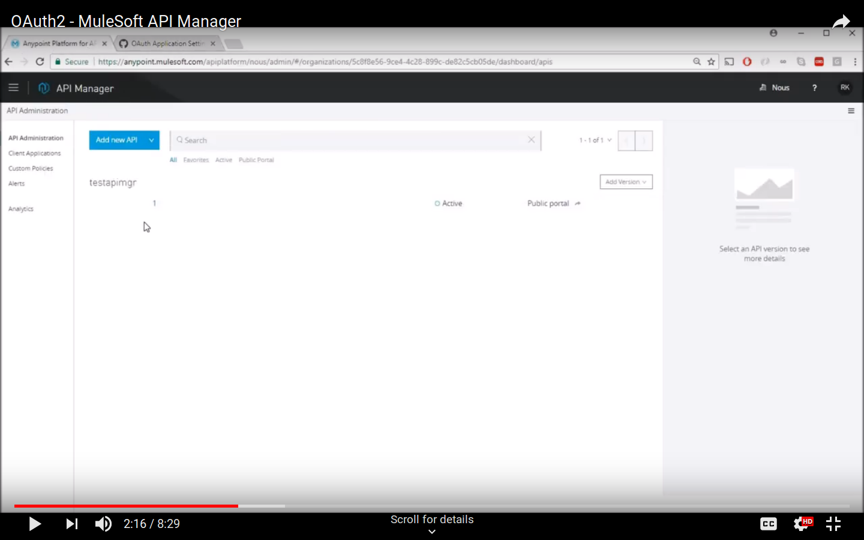

3. After opening API Version at the left sife navigation tab, you will find policy section, click on it and add new policy and select Oauth 2.0 access token policy.

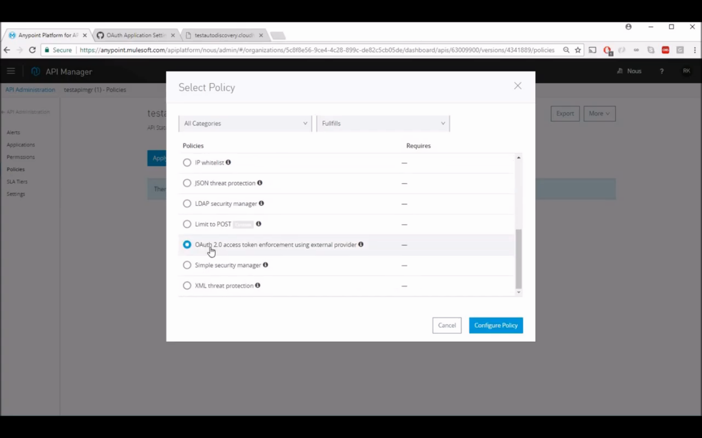
4. Provide following data and click “Apply” button

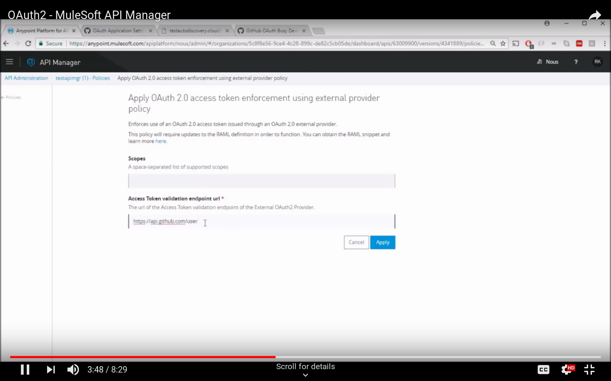

5. Configure oauth 2.0 settings at postman
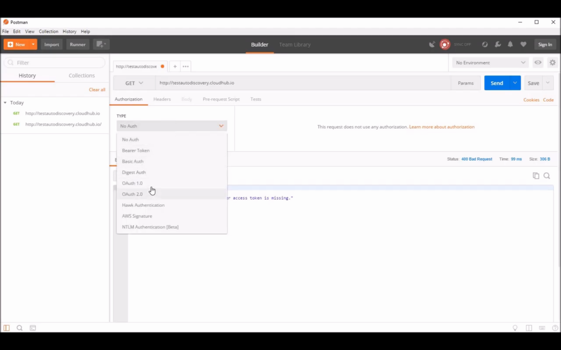

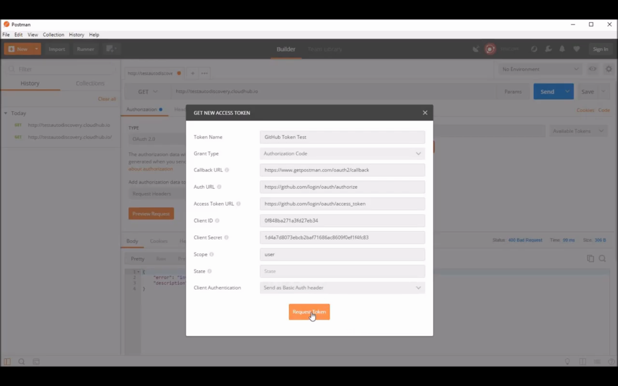

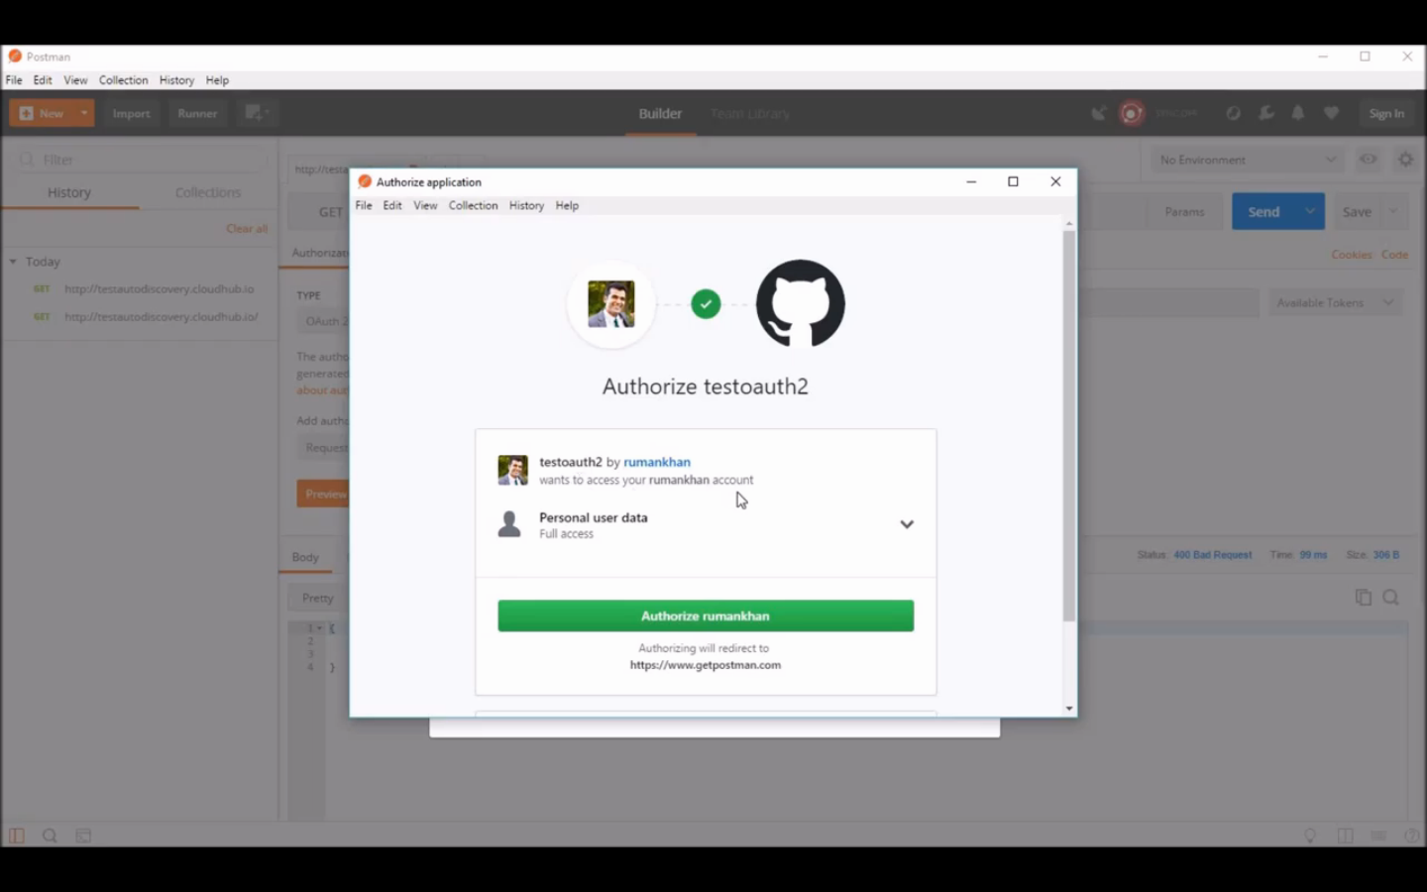
6. Success response received on valid token generation

